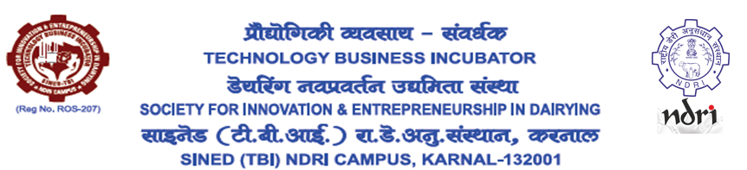
Managing Director
Qualification:
Essential : (i) Master of Business Administration (MBA) from a reputed Recognized Business School. /Post Graduate Diploma in Management (Agri Business Management)
Or
(ii) Professionals having Bachelor’s degree from a recognized institute/University in Dairy/Food/Agriculture/Animal Science.
Desirable: 3 years of working experience in running an enterprise preferably a TBI/STEP/BPD/ABI with good communication skills and proven leadership qualities.
Job description:
Responsibilities include taking lead in organizing the various activities, liaison with the Potential incubates/Dairy and Food Industries/Financial Institutions and work out a feasible work plan as per the requirements of NDRI & TBI, organization of training programmes vis-à-vis mandated activities, overall Financial/resource management for the TBI etc.
Salary: Rs. 9 lakh per annum (Consolidated).
Age limit: Maximum 60 years
The post is purely contractual for one year with a scope for further extension based on the performance - mostly in terms of number of incubatees joined, revenue earned to make the TBI financially self-sustaining, etc. No correspondence/ representation will be acceptable on termination after or before one year. The President, SINED-TBI will have full power to reject any application or terminate without giving any reason.
Candidate must apply by sending their CV in the given format (Page 2 and 3) by email: stbindri@gmail.com by 10/12/2022. The subject of the email should be: Application for the Post of MD-SINED-TBI - Applicant Name
APPLICATION FORM FOR THE POST MD (SINED-TBI, NDRI)

Affix Photograph Here

Sr. No. | Particulars
1 | Full Name  (in Capital Letters)
2 | Fathers/ mothers name
3 | Address (Present)
4 | Address (Permanent)
5 | Contact No.
6 | Email.
7 | Id Proof.  No.
8 | Date of Birth and age on 01/12/2022 in years and months

9. Educational qualification:

Sr. No. | Name of the School/Institute/University | Name of the degree | Percentage of marks | Year of passing | Position held (if any)

10. EXPERIENCE DETAILS:

Sr. No. | Name of the organization &  Address | Job description | Position held | Period from | Period  to

11. Relevant Trainings/ Certificates:

Sr. No | Title of Training/ certificate | Training Institution | Period  from | Period  to

12. Any other information you may like to provide in support of your candidature (describe within 200 words)

I hereby declare that all the information furnished above are true to the best of my knowledge and belief.
(Signature)
(Enclose photocopies of documents in support of above.)

